Chapter 15 Racial, Economic, and Political Change

TRUE/FALSE

1. Matthew Perry was the chief lawyer of the NAACP in South Carolina.

ANS: T PTS: 1 DIF: Knowledge REF: Chapter 15 Section 1
TOP: Civil Rights

2. The National Guard was called to end violence at Clemson University over the admission of its first black student.

ANS: F
Clemson’s first black student was admitted peacefully after a number of legal issues were resolved.

PTS: 1 DIF: Knowledge REF: Chapter 15 Section 1
TOP: Civil Rights

3. South Carolina integrated its schools in 1956 to be in compliance with Brown v. Education.

ANS: F
True integration in South Carolina did not occur until 1970.

PTS: 1 DIF: Application REF: Chapter 15 Section 1
TOP: Civil Rights

4. The twenty-fourth amendment to the U.S. Constitution abolished the use of the literacy test as a condition for voting.

ANS: F
The twenty-fourth amendment to the U.S. Constitution abolished the use of the poll tax as a condition for voting.

PTS: 1 DIF: Knowledge REF: Chapter 15 Section 1
TOP: Civil Rights

5. South Carolina voters did not support the Equal Rights Amendment.

ANS: T PTS: 1 DIF: Knowledge REF: Chapter 15 Section 1
TOP: Civil Rights

6. Medicare was founded under President John F. Kennedy.

ANS: F
Medicare was founded under President Lyndon B. Johnson.

PTS: 1 DIF: Knowledge REF: Chapter 15 Section 1
TOP: Changing Society

7. South Carolina’s right-to-work law was an attempt to prevent labor unions from becoming strong and influential.

ANS: T PTS: 1 DIF: Comprehension
REF: Chapter 15 Section 2 TOP: Economic Change

8. The number of South Carolina workers employed by foreign countries has increased consistently since 1970.

ANS: T PTS: 1 DIF: Analysis REF: Chapter 15 Section 2
TOP: Economic Change

9. In 2012, over half of the electricity used in South Carolina is generated from coal.

ANS: F
In 2012, over half of the electricity used in South Carolina is generated in nuclear plants.

PTS: 1 DIF: Knowledge REF: Chapter 15 Section 2
TOP: Economic Change

10. The Orangeburg Massacre resulted from protests at a bowling alley.

ANS: T PTS: 1 DIF: Knowledge REF: Chapter 15 Section 3
TOP: Civil Rights

11. The campaign of 1970 was the last time race was a major issue in South Carolina.

ANS: T PTS: 1 DIF: Knowledge REF: Chapter 15 Section 3
TOP: Political Change

MULTIPLE CHOICE

1. The decade of the 1960s opened with a civil rights march to protest the treatment of Jackie Robinson, a baseball hero, when he entered
a. | a restaurant.
b. | a gymnasium.
c. | a public park.
d. | a waiting area in an airport.

ANS: D PTS: 1 DIF: Knowledge REF: Chapter 15 Section 1
TOP: Civil Rights

2. Who was one of the founders of citizens’ schools to teach literacy and train citizens to vote?
a. | Septima Poinsette Clark
b. | Nikki Haley
c. | Martin Luther King, Jr.
d. | Jackie Robinson

ANS: A PTS: 1 DIF: Knowledge REF: Chapter 15 Section 1
TOP: Civil Rights

3. In what state was the first sit-in held?
a. | Alabama
b. | Georgia
c. | North Carolina
d. | South Carolina

ANS: C PTS: 1 DIF: Knowledge REF: Chapter 15 Section 1
TOP: Civil Rights

4. What group organized the freedom rides?
a. | CCC (Civilian Conservation Corps)
b. | CORE (Congress of Racial Equality)
c. | NAACP (National Association for the Advancement of Colored People)
d. | SCLC (Southern Christian Leadership Conference)

ANS: B PTS: 1 DIF: Knowledge REF: Chapter 15 Section 1
TOP: Civil Rights

5. What Supreme Court case allowed peaceful protest marches to be held?
a. | Brown v. Board of Education | c. | Green v.New Kent County
b. | Edwards v. South Carolina | d. | Plessy v. Ferguson

ANS: B PTS: 1 DIF: Comprehension
REF: Chapter 15 Section 1 TOP: Civil Rights

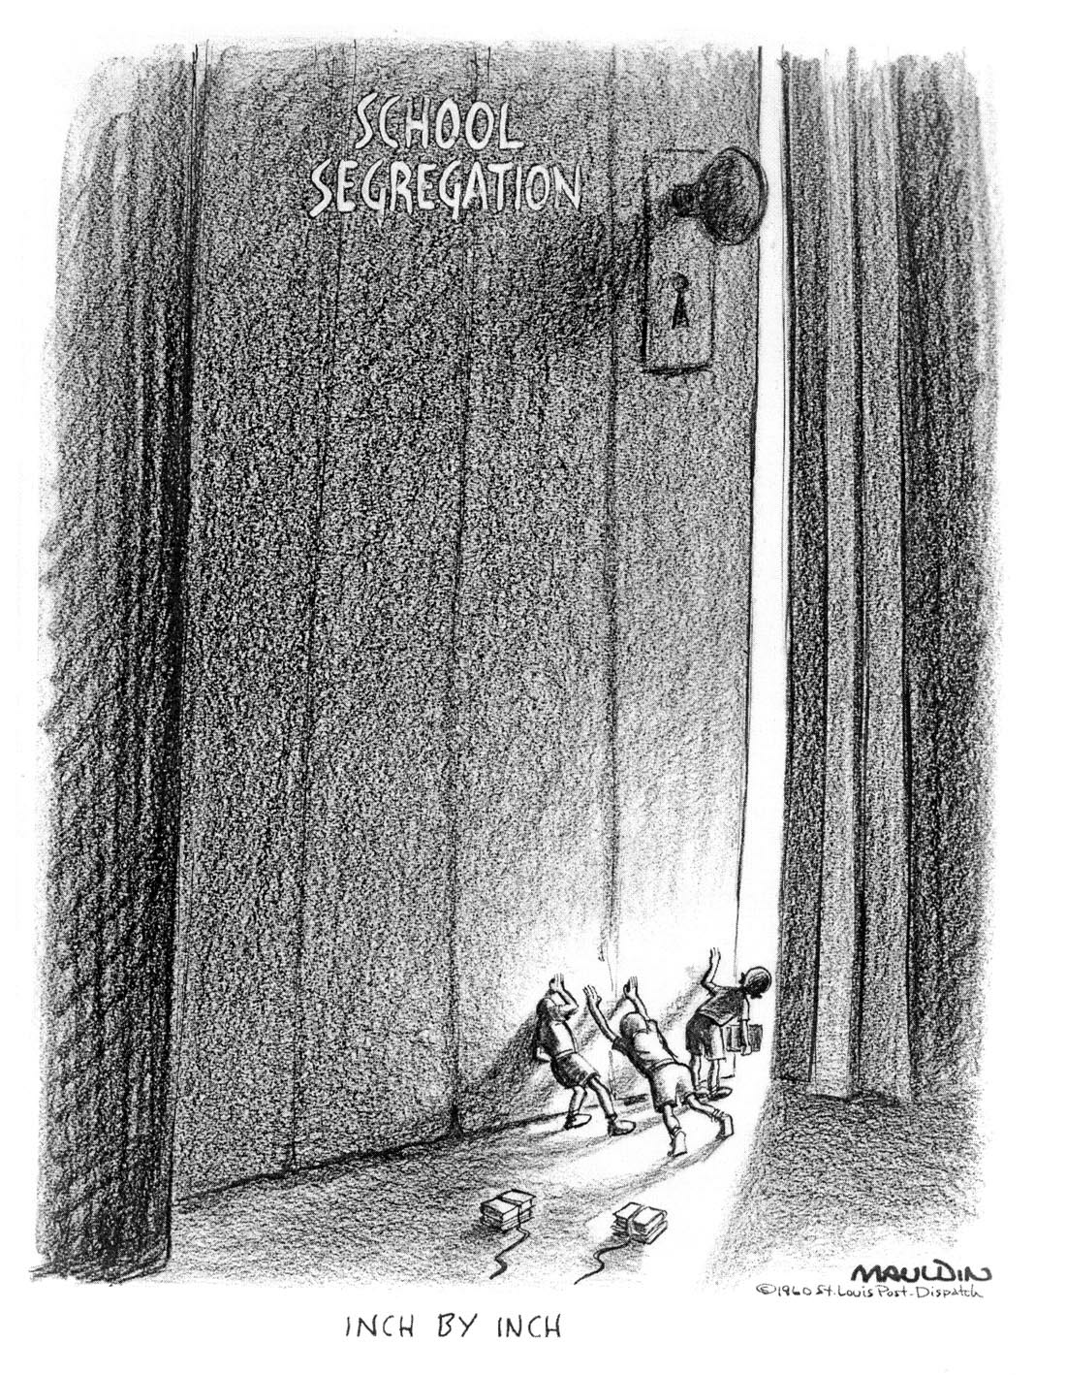

6. What is the subject of the political cartoon?
a. | discrimination
b. | the Ku Klux Klan
c. | segregation
d. | voting rights

ANS: C PTS: 1 DIF: Analysis REF: Chapter 15 Section 1
TOP: Civil Rights

7. During what time was the cartoon probably drawn?
a. | 1940s
b. | 1950s
c. | 1960s
d. | 1970s

ANS: C PTS: 1 DIF: Analysis REF: Chapter 15 Section 1
TOP: Civil Rights

8. What title best represents the subject of the cartoon?
a. | Change is a Long, Slow Process
b. | Education Opens the Door to the Mind
c. | Students Take Early Steps to Graduation
d. | Learning Doesn’t End at the Schoolhouse Door

ANS: A PTS: 1 DIF: Analysis REF: Chapter 15 Section 1
TOP: Civil Rights

9. Who was the first black student to apply for admission at Clemson University?
a. | Harvey Gantt
b. | James Meredith
c. | Rosa Parks
d. | James Solomon

ANS: A PTS: 1 DIF: Knowledge REF: Chapter 15 Section 1
TOP: Civil Rights

10. What Supreme Court case ordered states to establish unitary, integrated school systems?
a. | Brown v. Board of Education
b. | Edwards v. South Carolina
c. | Green v. New Kent County
d. | Plessy v. Ferguson

ANS: C PTS: 1 DIF: Analysis REF: Chapter 15 Section 1
TOP: Civil Rights

11. President Lyndon Johnson’s War on Poverty was part of his program known as the
a. | Future is Ours.
b. | Great Society.
c. | New Deal.
d. | New Tomorrow.

ANS: B PTS: 1 DIF: Knowledge REF: Chapter 15 Section 1
TOP: Changing Society

12. What was the mission of the State Development Board created in 1954?
a. | provide training for the state’s workers
b. | get business from other states and countries
c. | turn rural, non-productive land into tourist attractions
d. | develop a first class educational system

ANS: D PTS: 1 DIF: Application REF: Chapter 15 Section 2
TOP: Economic Change

13. In the 1960s, what two cities took the lead in seeking European manufacturers to locate in South Carolina?
a. | Spartanburg and Greenville
b. | Greenville and Columbia
c. | Charleston and Aiken
d. | Beaufort and Charleston

ANS: A PTS: 1 DIF: Knowledge REF: Chapter 15 Section 2
TOP: Economic Change

14. In what industry are most workers in South Carolina employed today?
a. | technology
b. | textiles
c. | tourism
d. | transportation

ANS: C PTS: 1 DIF: Analysis REF: Chapter 15 Section 2
TOP: Economic Change

15. What product makes up one-third of the income of South Carolina’s farmers?
a. | boilers
b. | cotton
c. | peaches
d. | hay

ANS: A PTS: 1 DIF: Knowledge REF: Chapter 15 Section 2
TOP: Economic Change

16. Which group was NOT one of the coalition that supported the Republican Party?
a. | supporters of white supremacy
b. | economic and social conservatives
c. | people who favored government aid
d. | people from the north who moved south for jobs or retirement

ANS: C PTS: 1 DIF: Analysis REF: Chapter 15 Section 3
TOP: Political Change

17. For which Republican presidential candidate did Strom Thurmond change parties in order to support?
a. | George Bush
b. | Barry Goldwater
c. | John McCain
d. | Ronald Reagan

ANS: B PTS: 1 DIF: Knowledge REF: Chapter 15 Section 3
TOP: Political Change

18. Which principle is NOT part of the southern strategy devised by Barry Goldwater?
a. | promise more states’ rights
b. | promote fewer social welfare programs
c. | continue to promote a strong national defense
d. | promote government aid for the unemployed and needy

ANS: D PTS: 1 DIF: Analysis REF: Chapter 15 Section 3
TOP: Political Change

COMPLETION

1. ________________ means to be on property without permission.

ANS: Trespass

PTS: 1 DIF: Knowledge REF: Chapter 15 Section 1
TOP: Vocabulary

2. A _________________ is a protest where people enter a public facility and refuse to leave until they are served.

ANS: sit-in

PTS: 1 DIF: Knowledge REF: Chapter 15 Section 1
TOP: Civil Rights

3. Another word for fiscal is ________________________.

ANS: financial

PTS: 1 DIF: Knowledge REF: Chapter 15 Section 3
TOP: Vocabulary

4. If someone is aggressive or radical, he or she is said to be ___________________.

ANS: militant

PTS: 1 DIF: Knowledge REF: Chapter 15 Section 3
TOP: Vocabulary

5. A law that protects a worker from having to pay union dues to get a job guarantees workers the ____________________________.

ANS: right to work

PTS: 1 DIF: Knowledge REF: Chapter 15 Section 2
TOP: Vocabulary

6. When legislative representatives are rearranged to meet population changes, the process is known as _______________________.

ANS: reapportionment

PTS: 1 DIF: Knowledge REF: Chapter 15 Section 3
TOP: Vocabulary

7. The movement of population from rural counties to cities is called ____________________.

ANS: urbanization

PTS: 1 DIF: Knowledge REF: Chapter 15 Section 3
TOP: Vocabulary

8. If something is obvious, it is said to be _______________________.

ANS: blatant

PTS: 1 DIF: Knowledge REF: Chapter 15 Section 3
TOP: Vocabulary

9. The voyages through the South by integrated groups to end segregation on Greyhound and Trailway buses and in bus terminals were called _____________________________.

ANS: freedom rides

PTS: 1 DIF: Knowledge REF: Chapter 15 Section 1
TOP: Civil Rights

10. One of the two steps toward equality for all people in the Civil Rights Act of 1964 was the provision that outlawed discrimination in ________________________________.

ANS:
employment opportunities
access to public accommodations

PTS: 1 DIF: Comprehension REF: Chapter 15 Section 1
TOP: Civil Rights

11. Besides blacks, the Civil Rights Act of 1868 addressed discrimination against _____________.

ANS: Indians

PTS: 1 DIF: Knowledge REF: Chapter 15 Section 1
TOP: Civil Rights

12. Single-member districts have tended to favor the _____________________ Party in South Carolina’s state-wide contests.

ANS: Republican

PTS: 1 DIF: Application REF: Chapter 15 Section 3
TOP: Political Change

13. The first crack in the monopoly of the Democrat Party in South Carolina was the ______________________ movement headed by Strom Thurmond.

ANS: Dixiecrat

PTS: 1 DIF: Comprehension REF: Chapter 15 Section 3
TOP: Political Change

14. The _______________________________ was the major South Carolina tragedy in the civil rights era.

ANS: Orangeburg Massacre

PTS: 1 DIF: Knowledge REF: Chapter 15 Section 3
TOP: Civil Rights

MATCHING

Match the governor with the statement describing something that occurred during his administration.
a. | James B. Edwards | d. | Donald S. Russell
b. | Ernest F. Hollings | e. | John C. West
c. | Robert E. McNair

1. refused to recognize unions as bargaining agents for workers

2. resigned as governor to take a vacant seat in the U.S. Senate

3. Orangeburg Massacre occurred

4. established Commission on Human Affairs

5. first black student enrolled at Clemson University while he was governor

6. established an educational television system

7. first Republican governor of South Carolina since Reconstruction

8. overhauled the Constitution of 1895

9. increased the work of the State Development Board

10. Education Finance Act provided more funds to poor schools

11. Charleston hospital workers strike occurred

12. convinced the legislature to create a technical education system

1. ANS: C PTS: 1 DIF: Knowledge REF: Chapter 15 Section 3
TOP: Political Change

2. ANS: D PTS: 1 DIF: Knowledge REF: Chapter 15 Section 3
TOP: Political Change

3. ANS: C PTS: 1 DIF: Knowledge REF: Chapter 15 Section 3
TOP: Political Change

4. ANS: E PTS: 1 DIF: Knowledge REF: Chapter 15 Section 3
TOP: Political Change

5. ANS: D PTS: 1 DIF: Knowledge REF: Chapter 15 Section 3
TOP: Political Change

6. ANS: B PTS: 1 DIF: Knowledge REF: Chapter 15 Section 3
TOP: Political Change

7. ANS: A PTS: 1 DIF: Knowledge REF: Chapter 15 Section 3
TOP: Political Change

8. ANS: E PTS: 1 DIF: Knowledge REF: Chapter 15 Section 3
TOP: Political Change

9. ANS: B PTS: 1 DIF: Knowledge REF: Chapter 15 Section 3
TOP: Political Change

10. ANS: A PTS: 1 DIF: Knowledge REF: Chapter 15 Section 3
TOP: Political Change

11. ANS: C PTS: 1 DIF: Knowledge REF: Chapter 15 Section 3
TOP: Political Change

12. ANS: B PTS: 1 DIF: Knowledge REF: Chapter 15 Section 3
TOP: Political Change

ESSAY

1. Describe the non-violent types of protests used during the civil rights movement.

ANS:
Answers will vary, but should include sit-ins, boycotts, marches, and freedom rides.

PTS: 1 DIF: Comprehension REF: Chapter 15 Section 1
TOP: Civil Rights

2. Describe the culture of the 1960s.

ANS:
Answers will vary, but may include:
Clothes: colorful, tie-dyed, worn blue jeans, miniskirts, loose, flowing
Behavior: more casual
Question authority: don’t trust anyone over 30
Drugs: experimenting with different drugs
Music: folk (Joan Baez, Pete Seeger); rock and roll (Chubby Checker); rock (Beatles,
Rolling Stones)

PTS: 1 DIF: Comprehension REF: Chapter 15 Section 1
TOP: Cultural Change

